Doing Small Things
with Great Love
(while waiting for Peace)

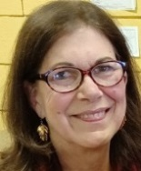

Dear Mission Friends:
Two years after the Russian invasion of Ukraine in February of 2022, not only is there no end in sight, but 10,000 civilians have been killed, countless cities have been destroyed, and despite many of us being currently distracted by the recent, heinous acts in Israel, perhaps even becoming desensitized to the sameness of the daily fighting in Ukraine, horrific death and destruction continue there.

Our Dominican friars are not allowed the time to become desensitized to the important causes to which they are devoted and which you, our Mission Friends, see fit to support. Their awareness of many of the world’s hot spots is in a constantly heightened state. As Fr. James Moore, O.P. recently put it upon being given a new assignment, “Our Dominican life is rooted in itinerancy—to be ready to go wherever the Gospel must be preached, and to adapt to the needs of the Order and the people of God.”

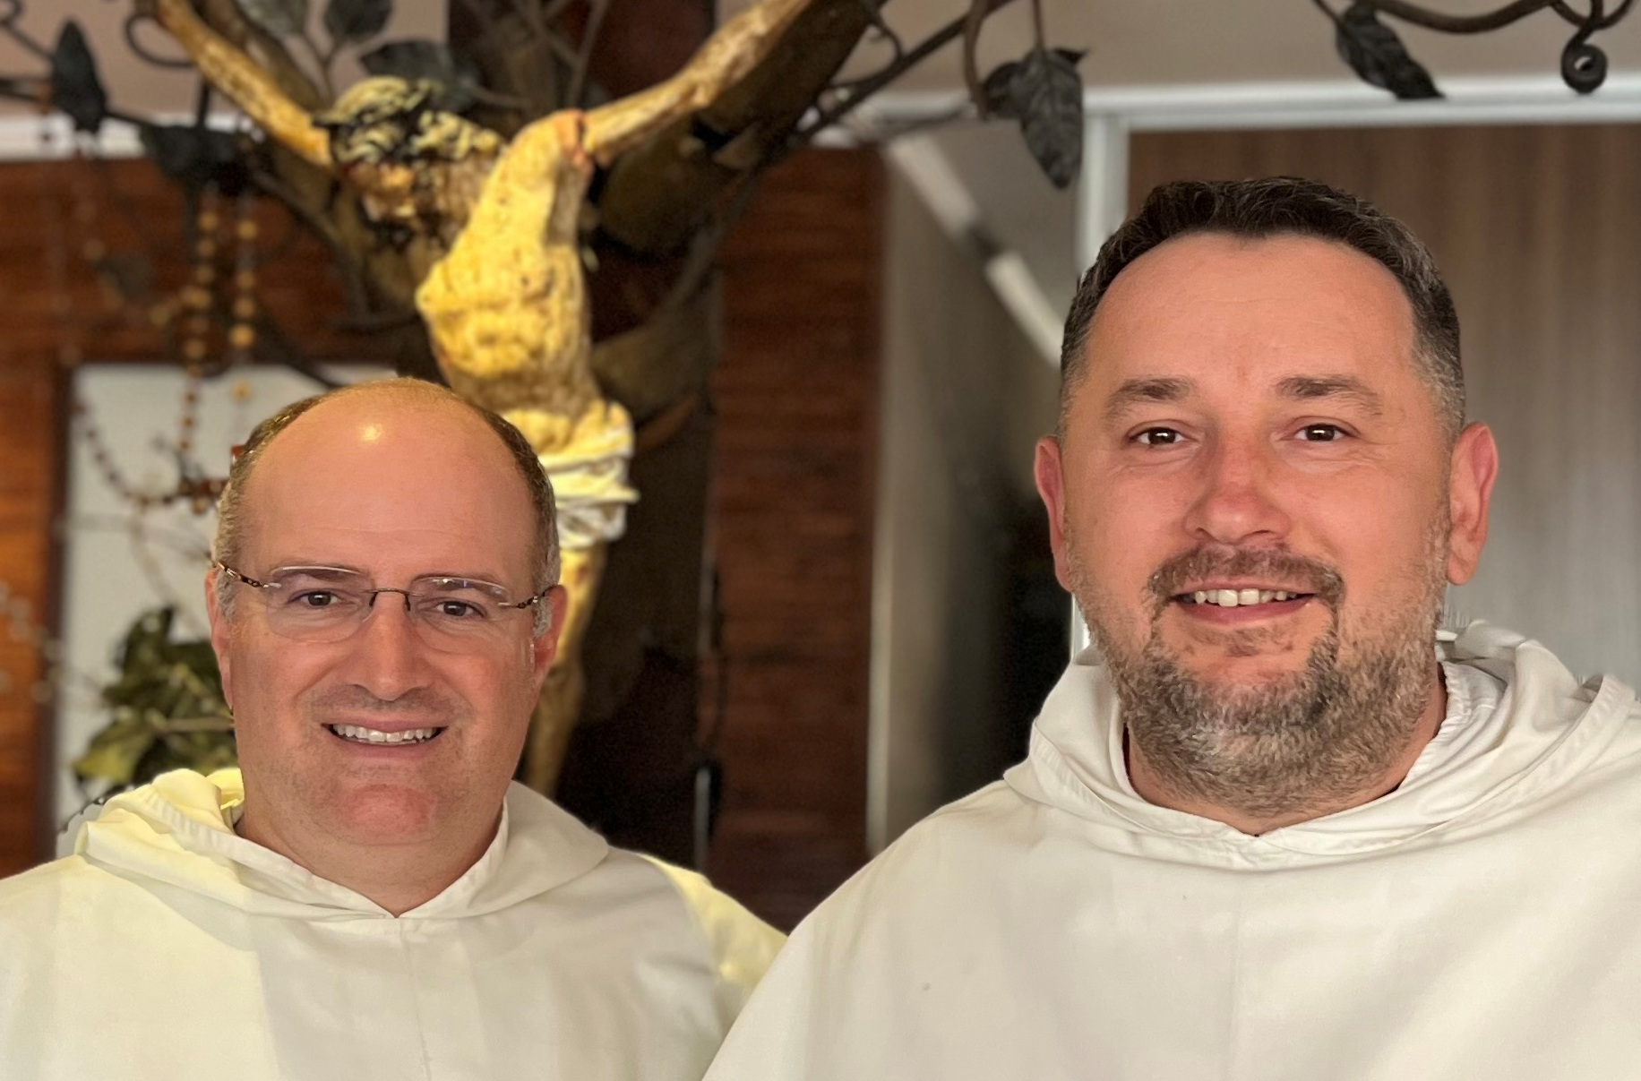
After serving seven years as the Western Dominican Province’s Vicar Provincial for Advancement, Fr. Moore has been called to begin a new chapter in his life—a call to serve as the Pastor of Holy Family Old Cathedral in Anchorage, Alaska, replacing Fr. Steven Maekawa, O.P., who has been appointed Bishop of the Diocese of Fairbanks. But before beginning his new assignment, Fr. Moore, whose energy and vitality rival those of our director-emeritus Fr. Martin de Porres Walsh, O.P., slipped in a trip to Ukraine last summer.

At the beginning of the Russian invasion of Ukraine, troops pierced deep into the country’s heart around Kyiv, causing heavy fighting as well as a mass exodus of the civilian population. Since then, the Province has been requesting donations to help support our Polish Dominican Brothers in their mission to care for the war’s victims and refugees. Between our Mission Office and our Province Advancement Office, we were able to raise $1.6 million within the first few months, and Fr. Moore wanted to go and see for himself how this huge collection was being put to use. Portions of his report follow:

“To enter Ukraine now, a no-fly zone under martial law, one has to take a train from the Polish border. While waiting at the station, I called my mom. ‘Don’t worry, Mom! I’ll be with my brothers!’ ‘I do worry,’ she responded. ‘You’re taking a train into a war zone. Trains make good targets!’

I also talked to several Ukrainians attempting to head back home. Many spoke English and were eager to tell this American priest of their experiences the past year and a half since Russia’s invasion of their country. One thing was obvious among them all—this invasion has galvanized them as a people. They were anxious to return to their home country, albeit much of it bombed and burned past recognition.

When I got to Kyiv after an overnight train ride, I was greeted by my Dominican brother, Fr. Jaroslow Krawiec, O.P., who is the Vicar of the Dominican Mission in Ukraine.

Page 2 Missionaries in Action Winter 2024

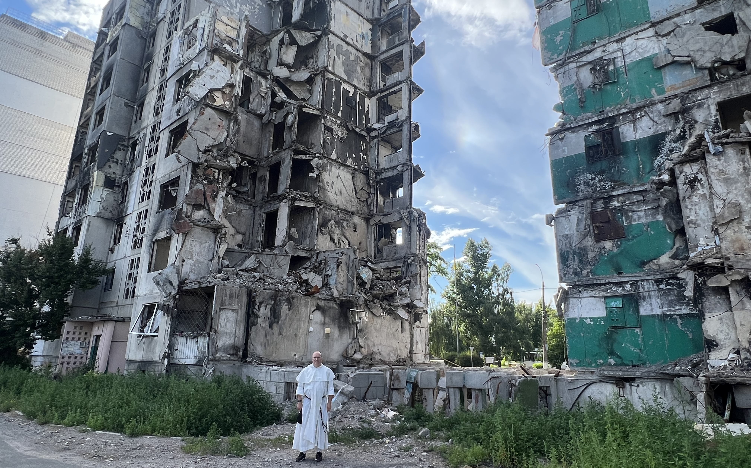

The Mission is under the direction of the Polish Province, but many native Ukrainians have joined since its founding in 1991 after the fall of the Soviet Union. We drove out to the western village of Fastiv where the Dominicans have restored the city’s Catholic church after years of Soviet occupation and desecration. They have also started a large social services program to teach the needy job skills as well as provide services for the handicapped and the elderly.

During the time of the USSR, only the able-bodied were of value and the elderly and the handicapped had few services available to them. Even now, 32 years after the fall of the USSR, government services are still scant for these vulnerable populations. The Dominicans in Fastiv responded by buying and beginning restoration of a dilapidated old building for use as a home for the handicapped and the elderly with a chapel in the middle. When the war broke out, the friars sprang into action, rushing construction along so that they could begin to house refugees there.

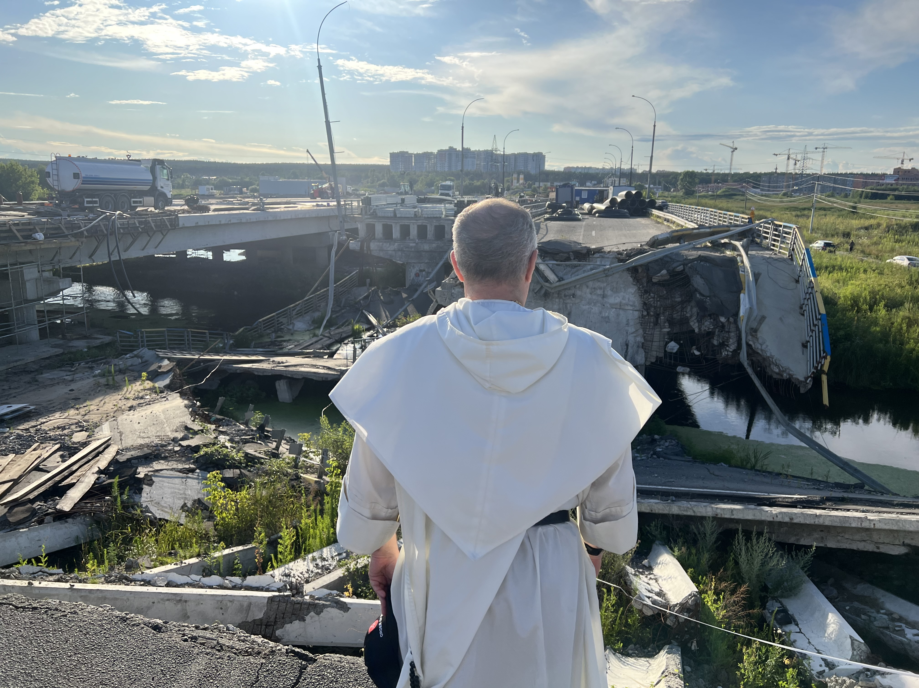

At first this meant hiding people in the basement of the church while bombs fell from the sky and ground troops came within a few kilometers of the town. The building was completed in record time, thanks in large part to donations you sent to our Mission and Province offices.

Today, in spite of constant air raids, many who have fled are attempting to return and seek normalcy, taking temporary shelter in our center. We assist those who make their way there with food, clothing, and supplies, much of which comes from the generosity and goodness of you, our Mission Friends. I met one woman who was Ukrainian Orthodox from near Bakhmut, the site of horrendous fighting. She escaped with her 10-year-old son but all of the other males in her family had been killed. An elderly couple’s home and family’s legacy had been demolished. Another woman, pregnant and accompanied by her older children, had barely escaped with their lives, but her husband was missing and most likely killed. These stories were almost unbearable to hear.

I don’t know how someone without faith could deal with such grief…

We soon drove back to the Dominican Priory in Kyiv, passing through several cities that had been the scene of bloody battles. In every place that we saw destruction, however, we also saw construction—the people are rebuilding and trying to secure hope for the future. After settling in for the night in the priory in Kyiv, however, our peace was broken around 2:00 a.m. with the wail of air raid sirens. Ukraine’s current technology includes the ability to shoot down most rockets, but the shrapnel still falls from the sky. I was on the top floor and could hear my mother say, ‘Get to the bomb shelter!’ So I went to the shelter and checked online for the all clear signal. It was a surreal experience to say the least!
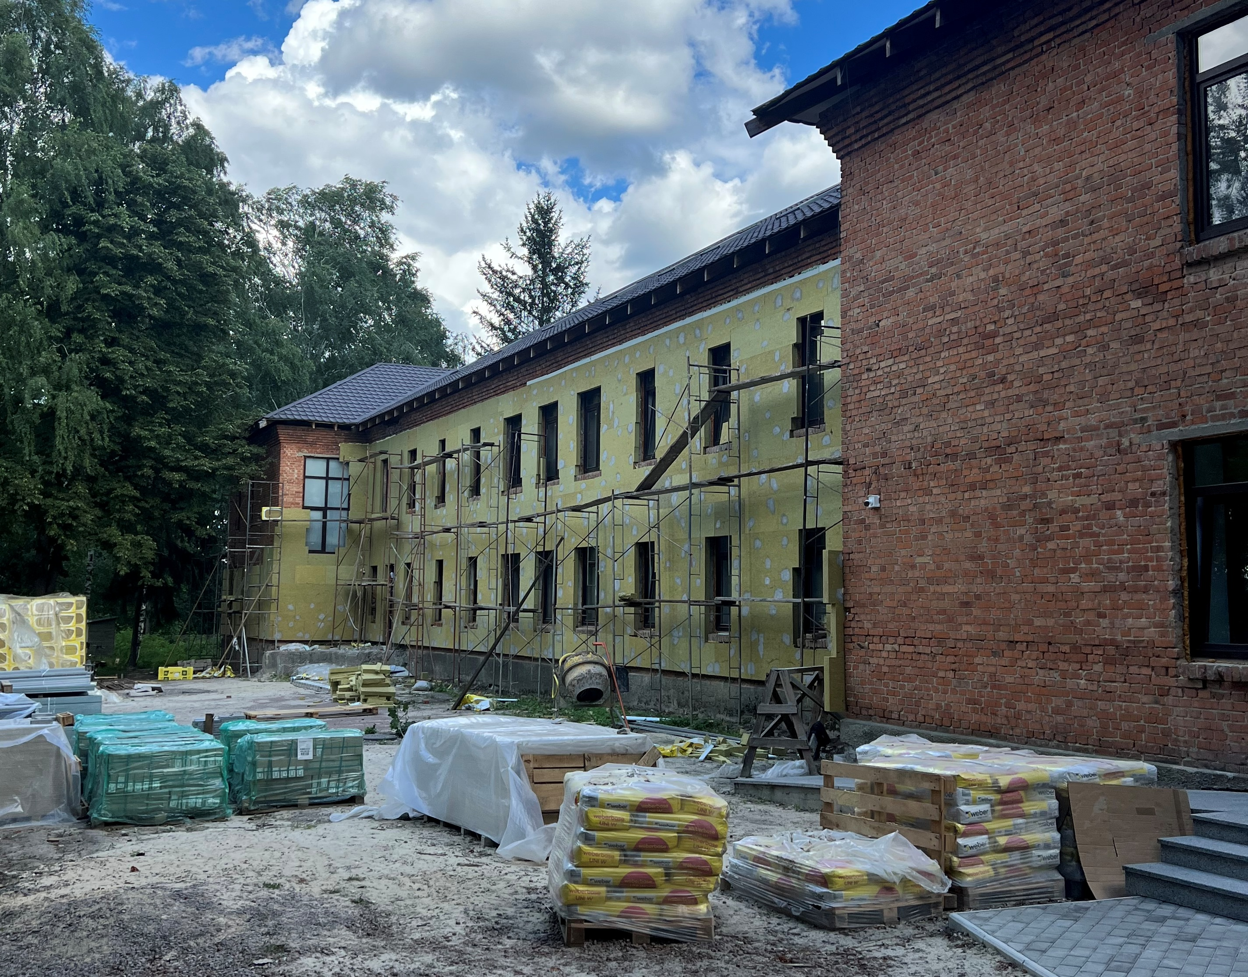

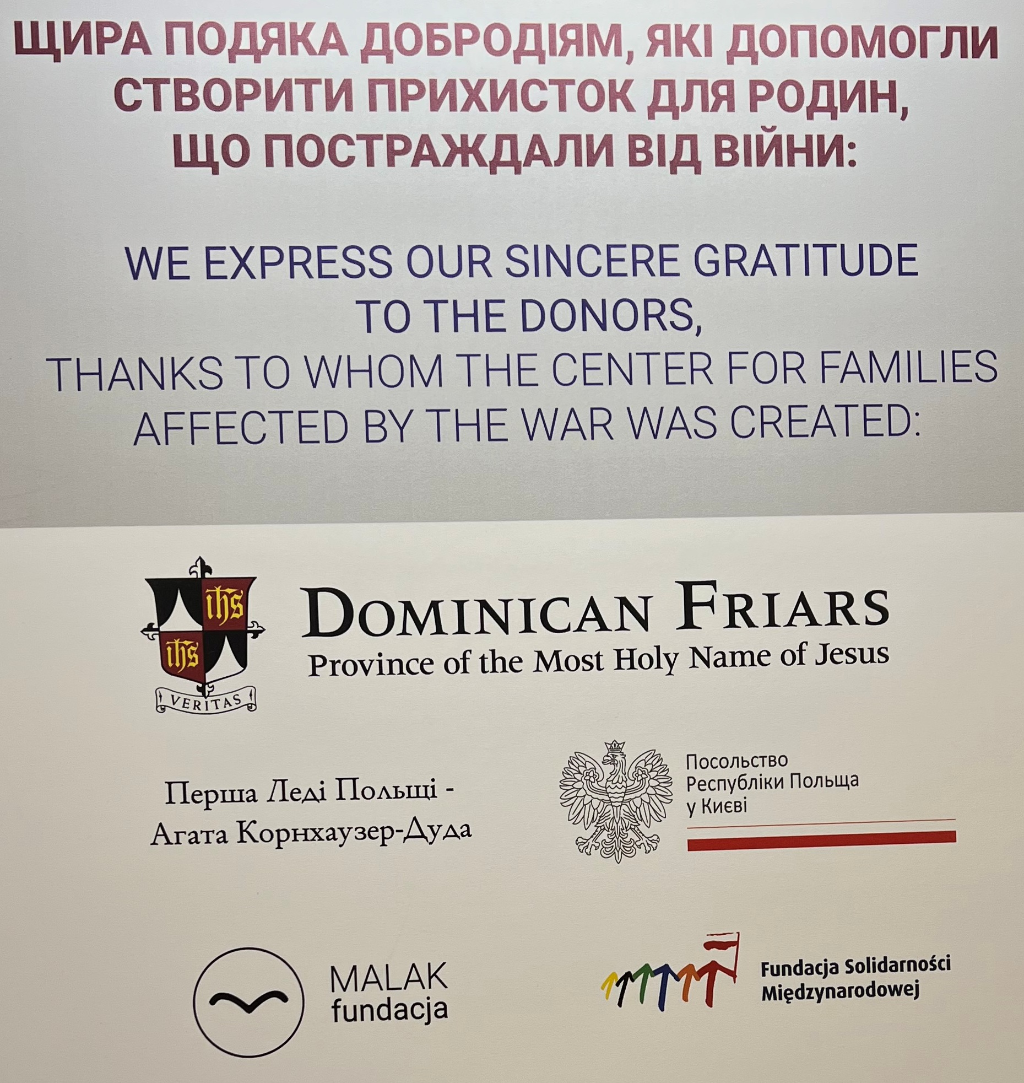
Winter 2024 Missionaries in Action Page 3

Still, it was a joy to be with my selfless, tireless Dominican brothers and to see the resilience of the Ukrainian people in the midst of this war. One interesting sign of hope and return to normalcy which brought cheers from the entire city was the reopening of McDonald’s after being closed for over a year.
However, for me there were two other more powerful signs of hope: First, the reopening of our Dominican Thomistic Institute in Kyiv, which is Ukraine’s only institution of higher learning for Western Catholic Theology, representing a strong intellectual resistance. Despite the warfare, we Dominicans continue to form new Catholic disciples! And second, the uninterrupted presence of Mother Teresa’s Sisters—the ever inspirational Sisters of Charity! They continue to serve the poor of Kyiv regardless of religion or race or their own persecution, and in the midst of the atrocities of war. I was able to celebrate Mass and preach at their convent since all of their liturgies are in English.
But fighting continues, now mostly along the eastern front, where it is incredibly brutal and where the majority of the refugee crisis exists today.

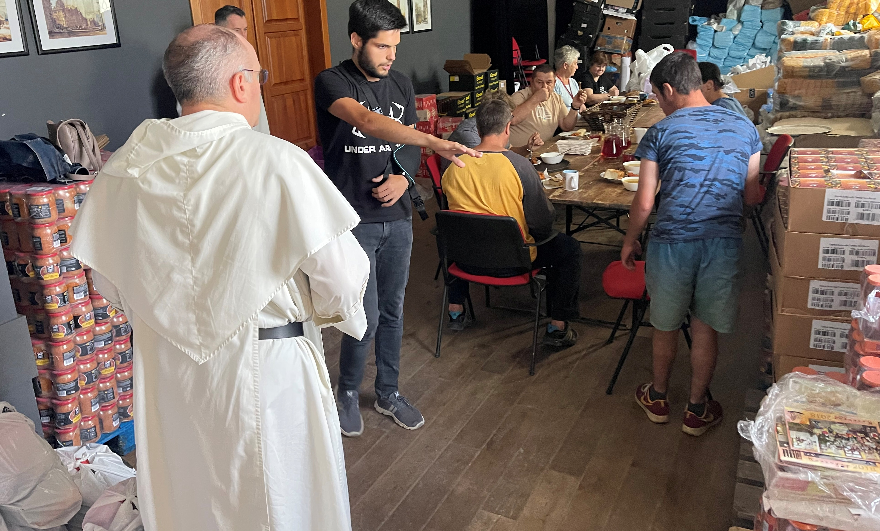

The Dominicans are maintaining the mission in Ukraine despite all of the dangers and difficulties of war, preaching the Gospel of Peace and strengthening the faith of others by their words and their deeds.
May the intercession of the Mother of God bring peace to our sad and war-torn world.
Fr. James Moore, O.P.”
p.1 left, Fr. James Moore, right,
Fr. Jaroslow Krawiec; p.2 top, Fr. Moore visiting destroyed towns; bottom, ‘Center for Families Affected by the War’ under construction; p.3 left, donor plaque;
right, Fr. Moore visiting supply rooms;
below, refugees he met at the center.

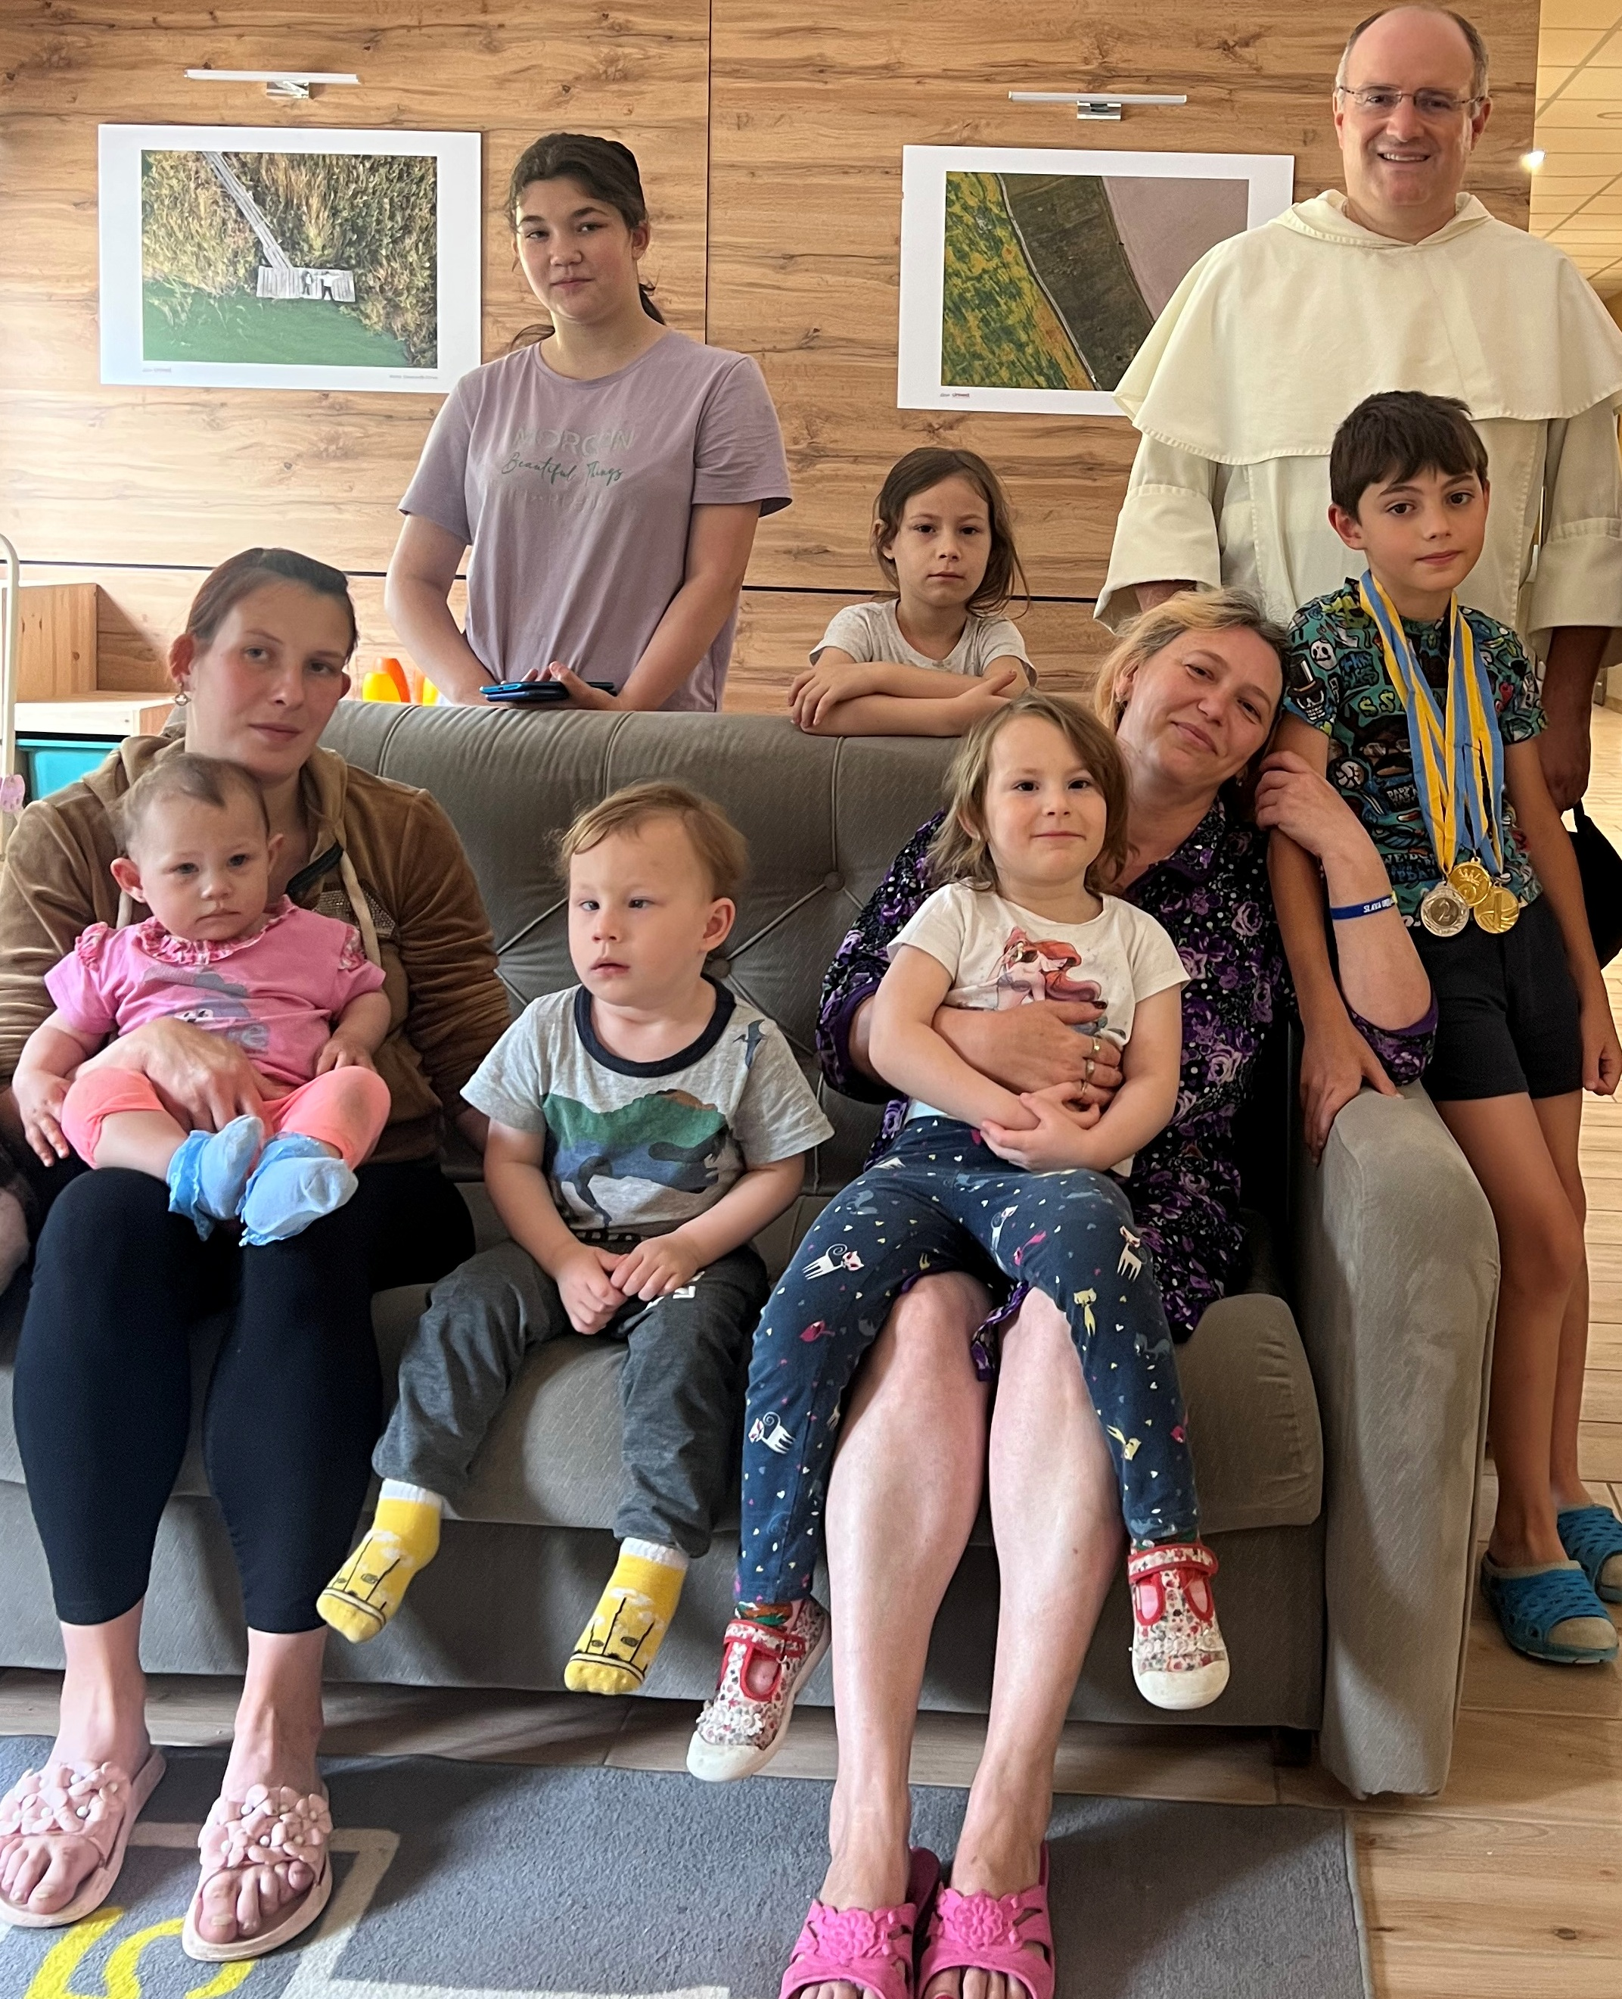

T
he last topic I wanted to reflect upon in this first newsletter of the New Year is war, but it’s impossible to avoid, or at the very least, feels wrong to do so. Wars have always been, are being, and always will be waged all over the world, between nations, tribes, gangs, etc. Major news stories are too often slanted, mistaken, or unreported altogether and the lines between sides can become blurry and even indistinct.

At the risk of exposing my naivete, I have been against war and violence since I can remember, marching and protesting, writing and arguing. I am well aware that there are crucial causes that must be defended and others that must be opposed. But I find it incredible that in this day and age we are still using guns and bombs and tanks to defeat the enemy of the moment. (As I write this on 1-6-24, at least 11 people, including five children, were killed by a Russian missile attack in and around the eastern Ukrainian town of Pokrovsk.) And the use of weapons such as chemical warfare or cyber warfare, while obviously not as primitive or crude, are at least as monstrous and vile. Nuclear warfare? Words fail.

And regardless of who “won” or will “win” any of the world’s wars, I must finally admit, in this later stage of my life, that human nature is a constant, that just as (Thank goodness!) there will always be mothers, like Fr. Moore’s mom, who worry no matter how old we are, there will always be wickedness and there will always be war. We won’t ever be able to stop war altogether, but we can and must do our part to protect the vulnerable, provide essential services, and alleviate the suffering of innocent victims.
Page 4 Missionaries in Action Winter 2024

The fact that the U.S., among many other countries, has sent Ukraine billions of dollars and tons of weapons and ammunition does not mean that your donations don’t count for much. We have close ties to the Dominican communities in Ukraine and Poland, ensuring that your gifts are received by them directly and totally and
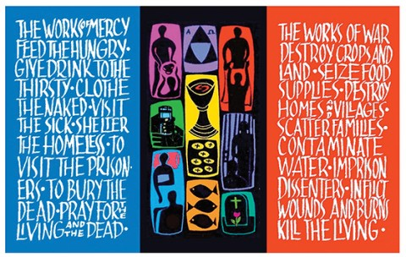

used for humanitarian purposes only (shelter, food, clothing, baby supplies, and medical supplies).
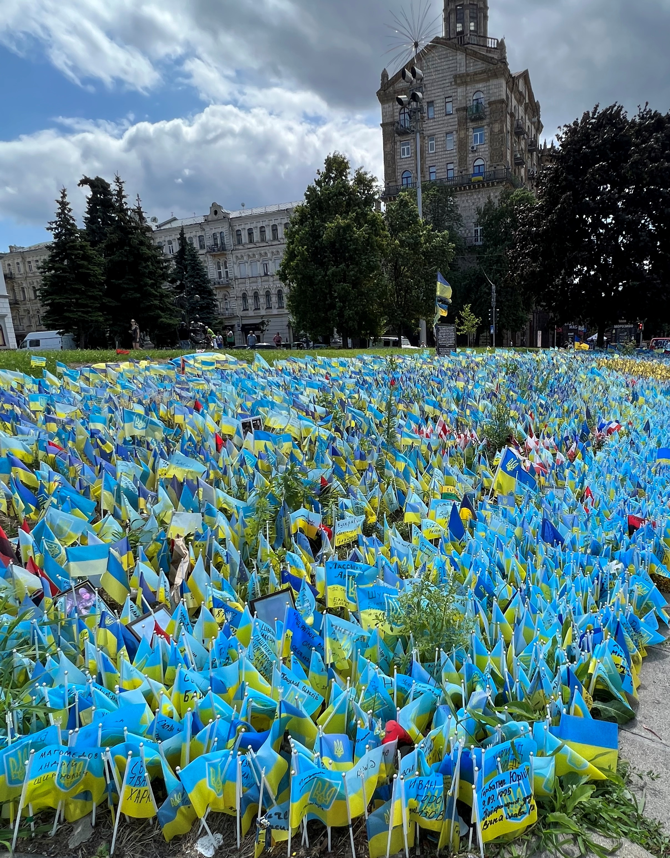

Fr. Jarosław wrote to thank us: “Ukrainian mothers, children, the elderly, sick, and injured...have found shelter and tender care in our Dominican priories...Our ministry of mercy toward so many victims of the war...would have been difficult, if not impossible, without the financial support shown to us by...so many people of good will. We would like to thank each of you most sincerely for your compassion...”
And, in the very final analysis, even if we fail in the moment to triumph over evil, to have lived in the service of ideal ends is to wrest from defeat a spiritual victory, which alone validates the effort and makes our struggle, as well as life itself, sublimely meaningful and worthwhile.

~Dr. Joseph Chuman

Dr. Joseph Chuman

As would we. Thank you, dear Friends, for all the works of mercy that you make possible.
Lesley Warnshuis

Ruth Carbin

Kyiv park filled with flags commemorating fallen victims of the war.

